**BLOG WITH RDS**

rds-dbinstance -create database-standard create ->mysql>mysqlcommunity>select the mysql version 8.0.35   
>free tier >setting(give the database name mydb)   
credentials(default admin)   
master password and confirm new password give it    
in db instance clas    
db.t3.micro   
storage is by default    
>connectivity >dont    
>public access >yes    
exisiting vpc >default    
available -us-east1-a   
in database option    
(mydb)   
take 5 to 7 min  sec to create instance --   
when instance is created endpoint is created  

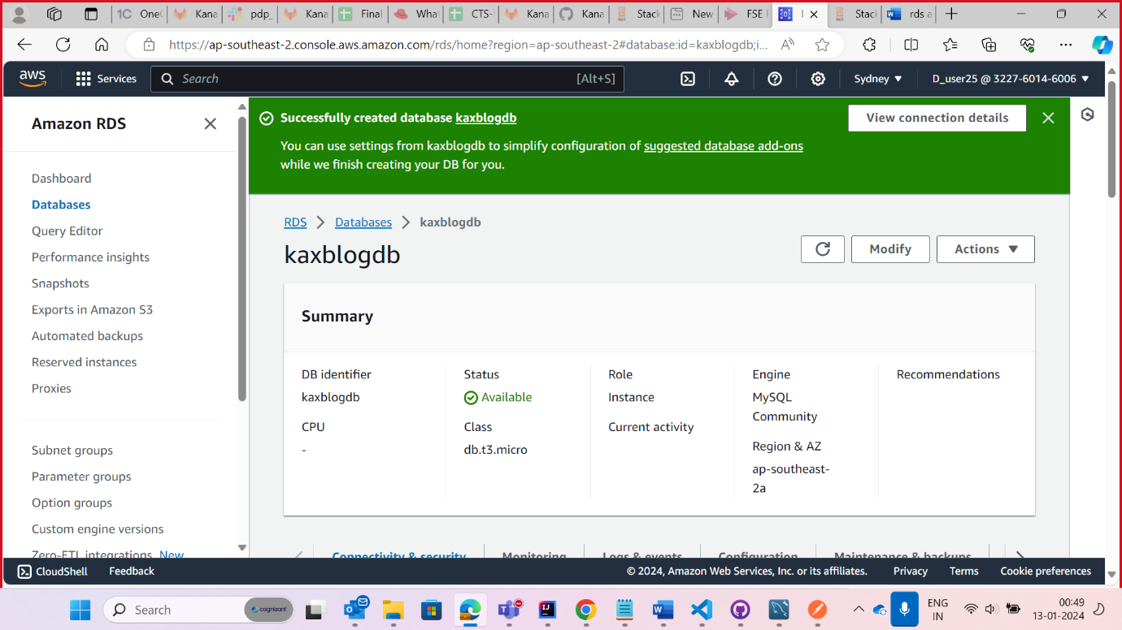

Create a Blog assignment and make the changes in the application.properties use the endpoint of the rds database

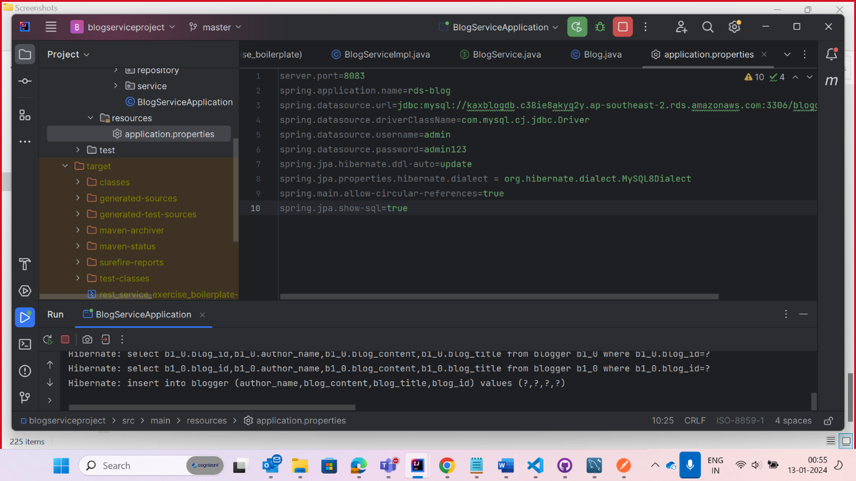

Check the postman whether the end point is working hence refer the screenshot

